
Capstone mid-Semester Progress Report
Comparative Customer Churn Prediction & Retention Strategy Analysis Across SaaS, Telecom, and Credit Card Industries

Sadikshya Shrestha

Introduction and Problem Statement
Customer churn is an important problem for a subscription-based business since it has a direct bearing on the predictability of revenues, the lifetime value of customers and marketing acquisition costs. Industries like Software as Service (SaaS), Telecommunications and Credit Card operate with recuring revenue model where retaining customers is cheaper compared to acquiring a new customer.
The main aim of the capstone project is to build predictive models churn for three industries under consideration using machine learning. The study aim is to identify at risk customers , understand the behavioral patterns affecting churn and make recommendations to improve the effectiveness of the customer retention strategy.

Overview of Data Acquisition & Preparation
Data Acquisition & Integration:
Three datasets were used, each specific to the industry which was obtained from publicly available sources on the Kaggle platform:
- Credit Card Dataset: This dataset consists of demographic information, transactional information, credit information and tenure information for around 10,000 customers.
- Telecom Dataset: This dataset consists of service plan information, contact information, billing information and churn information for around 7000 customers.
- SaaS Dataset: This dataset consists of multiple tables containing information about the profiles, subscriptions information, features usage support interactions and churn information.
A considerable amount of effort was required to combine the SaaS dataset as it has multi table dataset. Feature usage events and support interactions were aggregated to obtain significant feature usage metrics such as total feature usage intensity and support ticket frequencies for each account.
Example of data transformation used in SaaS:
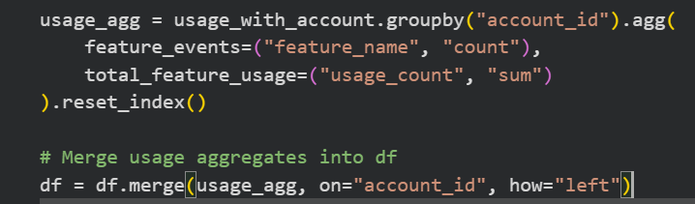
Figure 1 Data Tranformation used in Saas (Code)
These integration steps facilitate the formation of comprehensive analytical datasets that could be used for machine learning modeling.
Data Preparation
The data preparation steps include:
- Conversion of churn indicators into binary classification format.
- Elimination of unique identified variables to avoid overlifting of the models.
- Handling missing values using median imputation and logical substitution
- Identification and elimination of duplicate observations
- Correction of data types for billing and numerical engagement variables.
For instance, missing billing values in the telecom dataset were handled as follows:
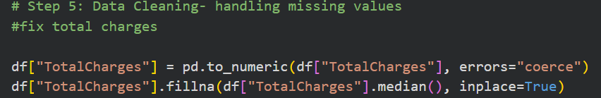
Figure 2 Handling missing values for Telecom (Code)

Exploratory Data Analysis
Exploratory Data Analysis (EDA) was carried out to uncover early churn trends and behaviors. Descriptive analysis showed the presence of variability in customer engagement and service usage across different industries.
Visualization techniques were employed to examine churn distribution and customer engagement behaviors. For instance, churn distribution analysis was carried out using count plots:
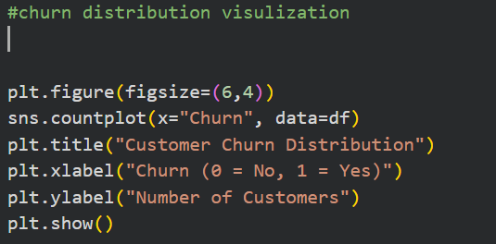
Figure 3 Code for churn distribution for visualization for Credit card
Important EDA findings:
Credit Card Industry: Customer with lower transaction volumes and higher credit utilization ratios were found to have a higher likelihood of churn.
Telecommunication Industry: Month to Month customers and those with higher monthly bills had a higher likelihood of not continuing their services.
SaaS Industry: Customers with lower feature usage intensity and higher support ticket rates had a strong association with churn behavior.
Correlation heatmaps were also used to emphasize the significance of engagement metrics as predictors of churn outcomes.
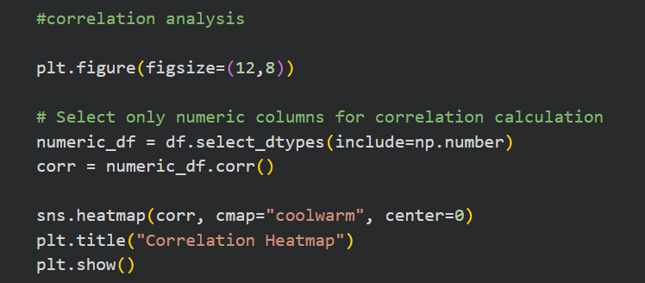
Figure 4 Correlation heatmap Code for Credit Card
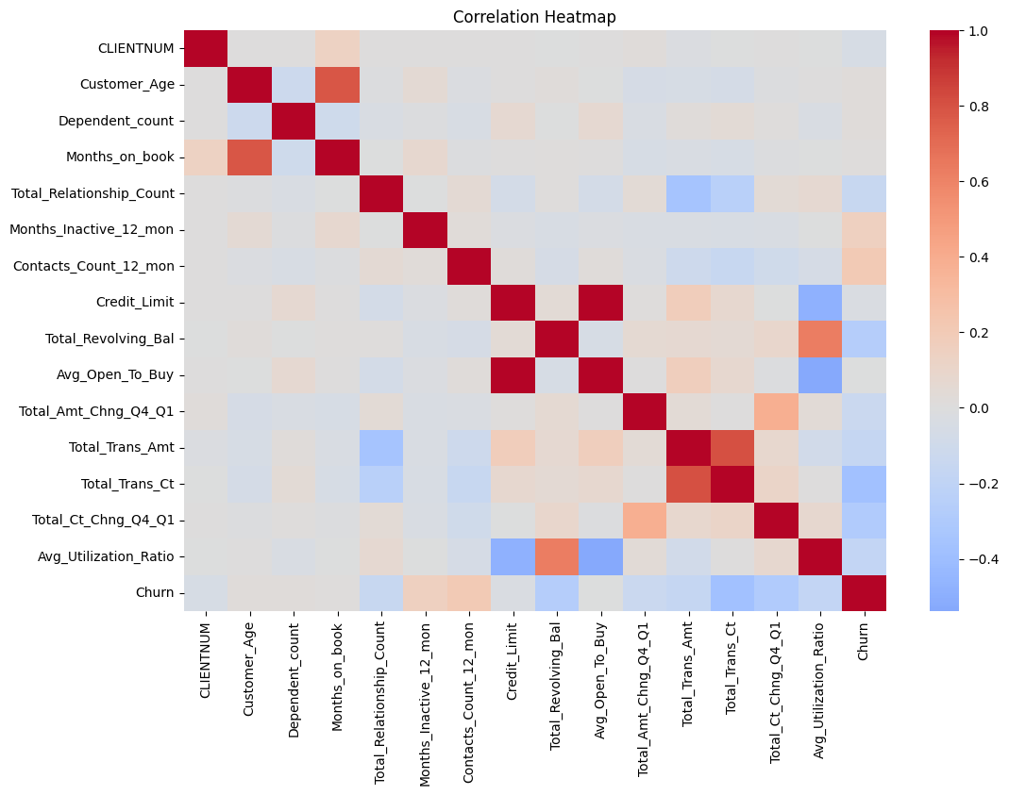
Figure 5 Credit Card Correlation Heatmap

Predictive Modeling Approach
For the purpose of customer churn predictions, three supervised machine learning algorithms were applied:
- Logistic Regressions
- Decision Tree
- Random Forest
The algorithm were tested for performance using a variety of metrics such as accuracy, precision, recall, F1-score and ROC-AUC to get a complete understanding of the classification performance.
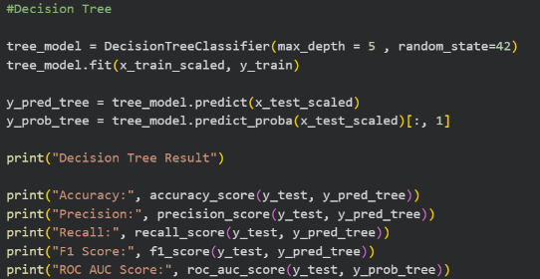
Example code for modeling:
Figure 6 SaaS - Code for Decision Tree Modeling
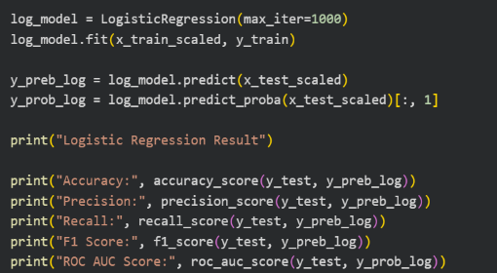
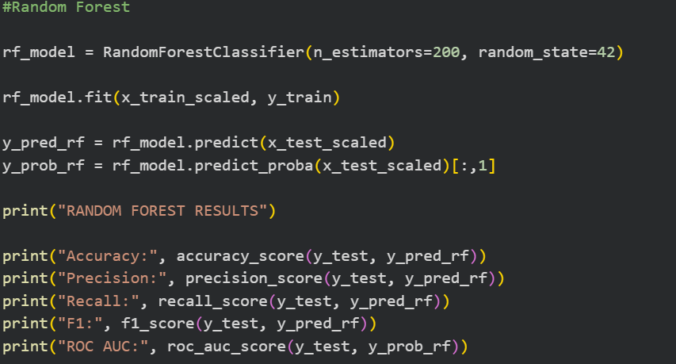
Figure 7 SaaS- Code for Logistic Regression Modeling
Figure 8 SaaS- Code for Random Forest
Modeling
Preliminary Modeling Findings
- Random Forest algorithm performed better than other algorithms on all datasets because of its capability to handle non-linear relationships.
- Logistic Regression algorithms offer interpretability advantages because of its ability to provide information on the direction and magnitude of the influence of the input variables
- Decision Tree algorithm allowed for the visualization of the decision making process for churn but had only moderate accuracy.

Preliminary Visualization Work
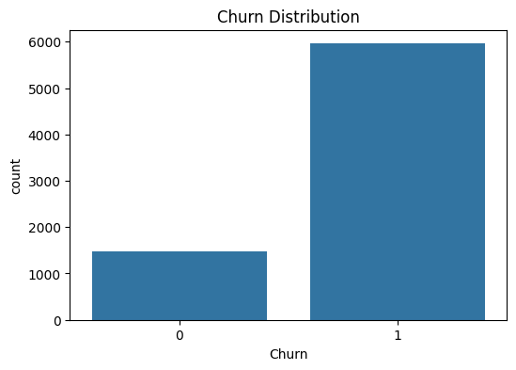
Preliminary visualization techniques were designed to facilitate an understanding of customer churn behavior and assist in the interpretation of predictive modeling outputs.
Churn distribution graphs were designed to analyze the distribution of retained and churned customers in various datasets which can help in identifying possible class imbalance and overall churn behavior.

Figure 9 Churn Distribution
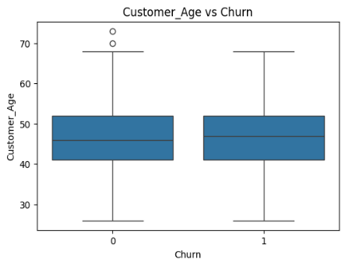
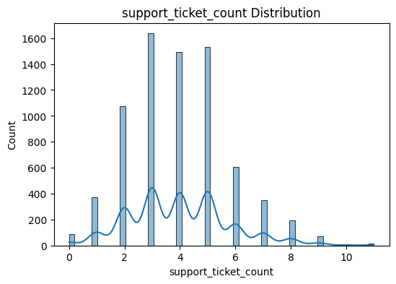
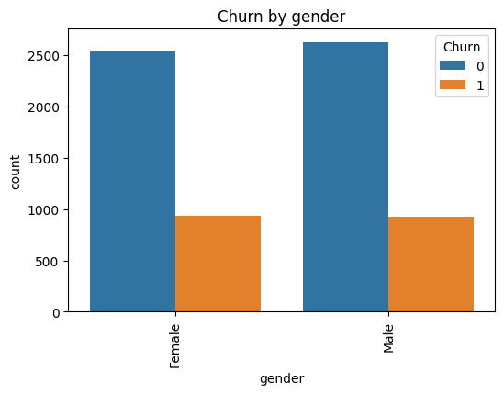
Figure 10 Credit Card - Customer Age vs Churn Distribution
Figure 11 SaaS-Churn Distribution by Ticket Count
Figure 12 Telecom- Churn Distribution

Model comparison graphs were also designed to assist in the visual comparison of the performance of Logistic Regression, Decision Tree and Random Forest models using key metrics such as accuracy, precision, recall, F1 score and ROC-AUC. These visuals tools can help in determining the best predictive model for churn prediction across various industry. 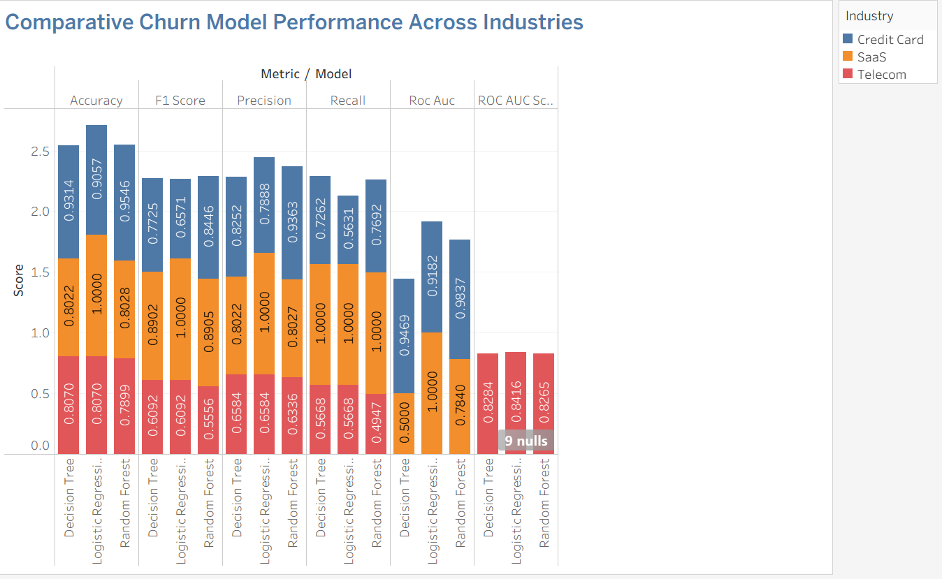
Figure 13 Churn Model Comparison across three industry
The customer segmentation charts are used to predicted probabilities of churn from the Random forest model to classify customers into low medium and high churn risk categories. The SaaS industry dataset reveals relatively greater number of medium-risk customers, which indicates moderate engagement and susceptibility to churn, while the telecom and credit card industry datasets reveal a relatively greater number of low-risk customers, which indicates relatively stronger retention levels. Nevertheless, the high-risk customer segments exist in all industries, and this underlines the need for focused retention strategies.
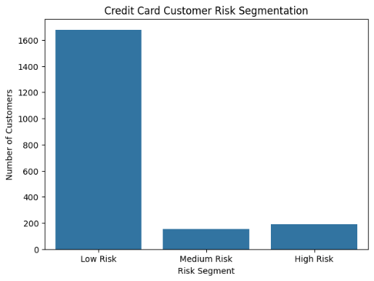
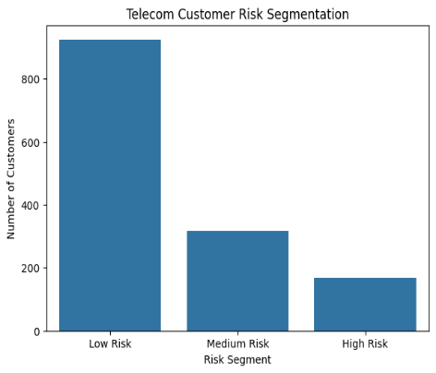
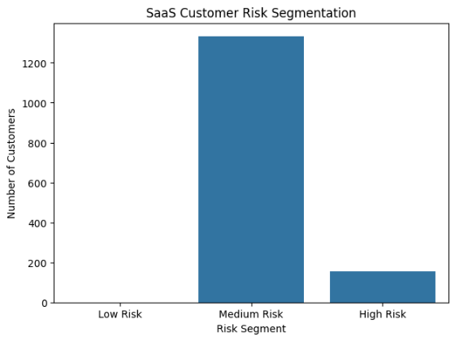
Figure 14 Credit Card Customer Segementation
Figure 15 Telecom Customer Segmentation
Figure 16 Saas Customer Segmentation
Furthermore, the churn risk segmentation datasets were created and formatted for integration into Tableau dashboards to facilitate the classification of customers into risk categories and the development of interactive visualizations.

Challenges Encountered
While doing analysis and data preprocessing steps several challenges were identified. In the SaaS dataset, the complexity of data integration because of various relational tables like accounts, subscriptions, feature usage logs and support tickets was a challenge. This made the process of forming a common dataset for analysis more complex. The problem was solved by using aggregation and merging strategies, which enabled the formation of behavioral engagement metrics at the customer account level.
In the telecom dataset, the existence of missing values and inconsistent formats in the billing data, especially in the total charges field, was a challenge. This problem was solved by correcting data types, using logical imputation by median values, and performing validation checks to ensure the accuracy and consistency of financial metrics.
Another important challenge was the need to ensure a standardized predictive modeling process for the credit card, telecom, and SaaS industries. Because the datasets were different in terms of structure and variables, a standardized approach to preprocessing, feature engineering, and evaluation was used. This was achieved by creating standardized data cleaning pipelines, encoding schemes, and model evaluation systems to ensure comparability of predictive accuracy across industries.

Planned Analytical Approach for Remaining Weeks
The following stages of this project will focus on:
- Hyperparameter optimization and performance optimization of machine learning models
- Development of customer churn risk segmentation frameworks
- Development of interactive Tableau dashboards for visual analytics
- Cross-industry comparative insights development
- Final strategic recommendations development.

Updated Timeline
Time | Week | Activities
March 23 – March 29 | Week 10 | Model refinement and churn risk segmentation implementation
March 30- April 5 | Week 11 | Tableau dashboard development and visualization analysis
April 6- April 12 | Week 12 | Interpretation of analytical findings and recommendation drafting
April 13- April 27 | Week 13 | Final report writing, dashboard refinement, and presentation preparation

Conclusion
The mid-semester progress report shows successful completion of the stages of data preparation, exploratory analysis, and predictive modeling. The preliminary results emphasize the significance of customer engagement features like transaction, service tenure, feature usage, and support interactions in predicting customer churn behavior.
The next phases will concentrate on improving predictive models, visualization dashboards, and strategic recommendations.

